|  |
| --- |
|  |
| Temperature Forecast Using ML  Tushar kumar patel |

* Overview
* Objective
* Introduction
* Import libraries
* Variables
* Pre-processing
* Missing values
* Handling missing values
* Exploratory Data analysis
* Heatmap
* Outlier Detection
* Outlier removal
* Skewness
* Model Building
* Train Test and split
* Evaluation metrics
* Hyperparameter tuning
* Conclusion

Sunshine is delicious, ran is refreshing, wind braces us up, snow is exhilarating, there is really no such thing as bad weather, only different kind of good weather. – John Ruskin



Objective

Our project aims is to predict the temperature using the previous dataset of the temperature forecasting with a focus on improving the accuracy of prediction. This will increase the accuracy of the temperature prediction and we will get accurate results than the traditional methods. Our dataset consists of max and min. temperature of everyday from the specific location.

When gathering datasets to give to the models there are some parameters which are called as ordered information which incorporates: humidity level, cloud cover, average precipitation, longitude, latitude, solar radiation, elevation, slope etc. Thus our aim is to provide accurate result in order to provide correct prediction of weather for future so in critical conditions people can be aware of upcoming natural conditions, what the temperature will be on that particular location.

Introduction

In this article, I would like to show how we can use a data science algorithm for temperature forecasting and compare some frameworks for classification and regression tasks.

**Temperature forecasting** is the application of science and technology to predict the temperature for a given location and time. People have attempted to predict the weather informally for millennia and formally since the 19th century. Temperature forecasts are made by collecting quantitative data about the current state of the atmosphere, land, and ocean and using meteorology to project how the temperature will change at a given place.

Once calculated manually based mainly upon changes in barometric pressure, current weather conditions, and sky condition or cloud cover, weather forecasting now relies on computer-based models that take many atmospheric factors into account.[[1]](https://en.wikipedia.org/wiki/Weather_forecasting#cite_note-1) Human input is still required to pick the best possible forecast model to base the forecast upon, which involves pattern recognition skills, teleconnections, knowledge of model performance, and knowledge of model biases. The inaccuracy of forecasting is due to the chaotic nature of the atmosphere, the massive computational power required to solve the equations that describe the atmosphere, the land, and the ocean, the error involved in measuring the initial conditions, and an incomplete understanding of atmospheric and related processes. Hence, forecasts become less accurate as the difference between current time and the time for which the forecast is being made (the *range* of the forecast) increases. The use of ensembles and model consensus help narrow the error and provide confidence level in the forecast.

Used Python Library

SKlearn

It is very useful library for machine learning modeling. It

initially released on 2007. It includes lot of machine

learning algorithms. In this library we use modules like

DecisionTreeClassifier, train_test_split, accuracy_score.

Numpy

It is basically used in mathematical operations. It reads

the data as numpy array for the manipulation purpose. It

provides fast mathematical functions for calculation. For

machine learning it is very common library.

Panda

This is the library make data analysis easier in python.

This library also used to read and write the files. With

data frame data manipulation can be easily done.

**Used Python Libraries**

* **Sklearn**

**It is very useful library for machine learning modeling. It initially released on 2007. It includes lot of machine learning algorithms. In this library we use modules like Decision Tree Classifier, train_test_split, accuracy_score.**

* **Numpy**

**It is basically used in mathematical operations. It reads the data as numpy array for the manipulation purpose. It provides fast mathematical functions for calculation. For machine learning it is very common library.**

* **Panda**

**This is the library make data analysis easier in python. This library also used to read and write the files. With data frame data manipulation can be easily done.**

* Variables

Dependent variable

Next day maximum temperature

Next day minimum temperature

Independent variable

Except Maximum and minimum temperature all other variables are independent variable.

The shape of the dataset is **7752 rows** and **25 columns**.

* Pre-processing

**The more you preprocess the dataset the more accurate result you will get. Basically, it is the process where we remove some unwanted or not useful, noisy data from the collected data. Also, if we don’t remove any null value or empty field then we cannot get the proper results. So, it is very important process to develop the model.**

* Data Preprocessing
* The more you preprocess the data set, the more accurate
* result you will get. basically, it is the process where we
* remove some unwanted or not useful, noisy data from the
* collected data. Also, if we don’t remove any null value or
* empty field then we cannot get the proper results.
* So, it is very important process to develop the model.
* Missing values

Before going for missing values I would like to know the summary of the dataset and then select a useful column for further analysis.

It can be seen that there is a large number of missing values in the dataset.

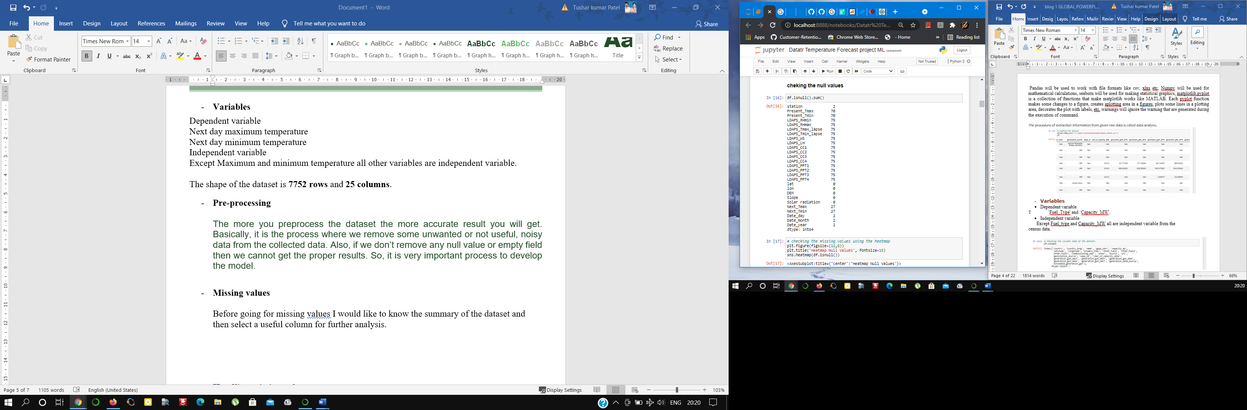

The missing values with the help of heatmap.



White line present in between the black line represents the missing values.

Now missing values requires the ways to fill the values.

* Handling missing values

There are many ways to fill the missing values.

1. Delete the observations.
2. Replace missing values with the most frequent value like Mean/Median/Mode.
3. Developing the model to predict missing values.
4. Deleting the variable.
5. Apply unsupervised Machine learning techniques.

Here I will use mean method for filling the missing values.

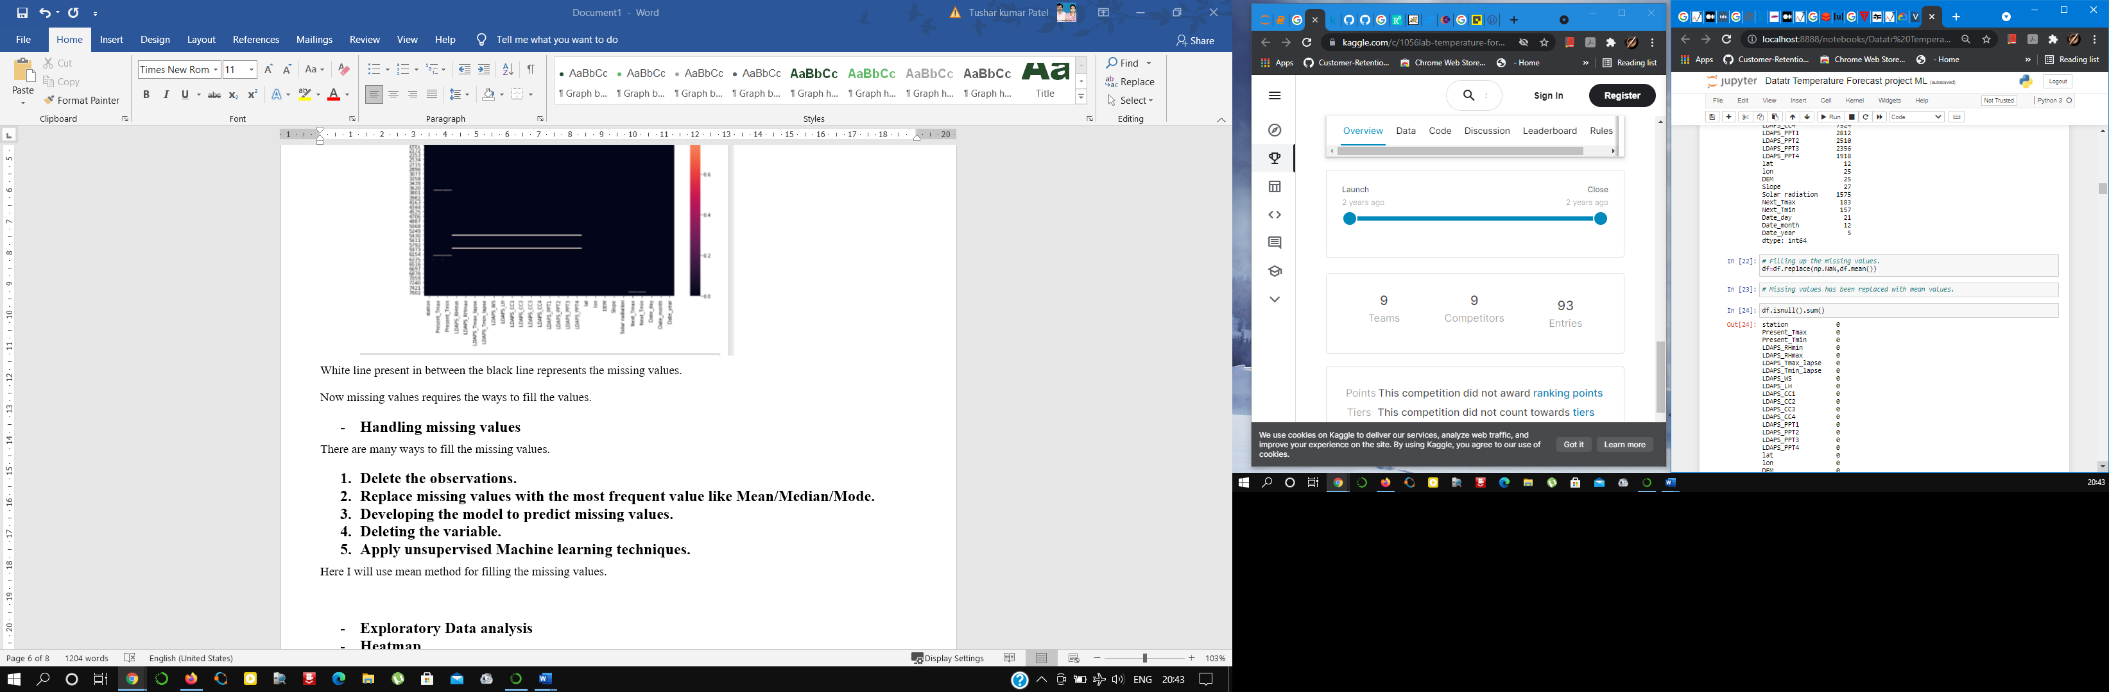

* Exploratory Data analysis

First I would like to plot the variation of **maximum temperature**. On the plot it can be seen that temperature varies between 18-38 degree Celsius.

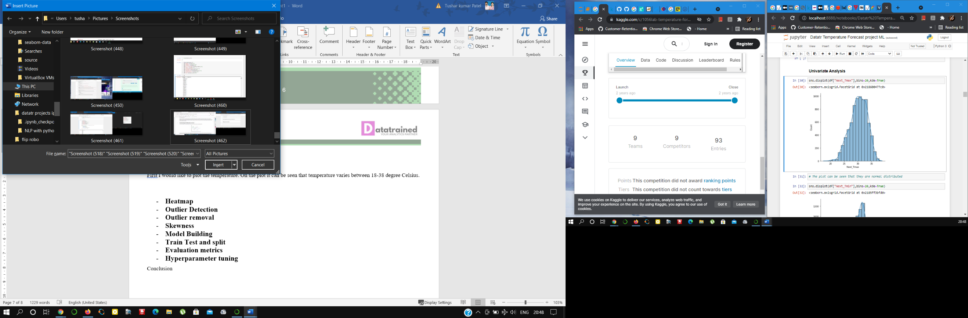

Next I will like to plot the variation of minimum temperature. On the plot it can be seen that temperature varies between 11-30 degree celsius

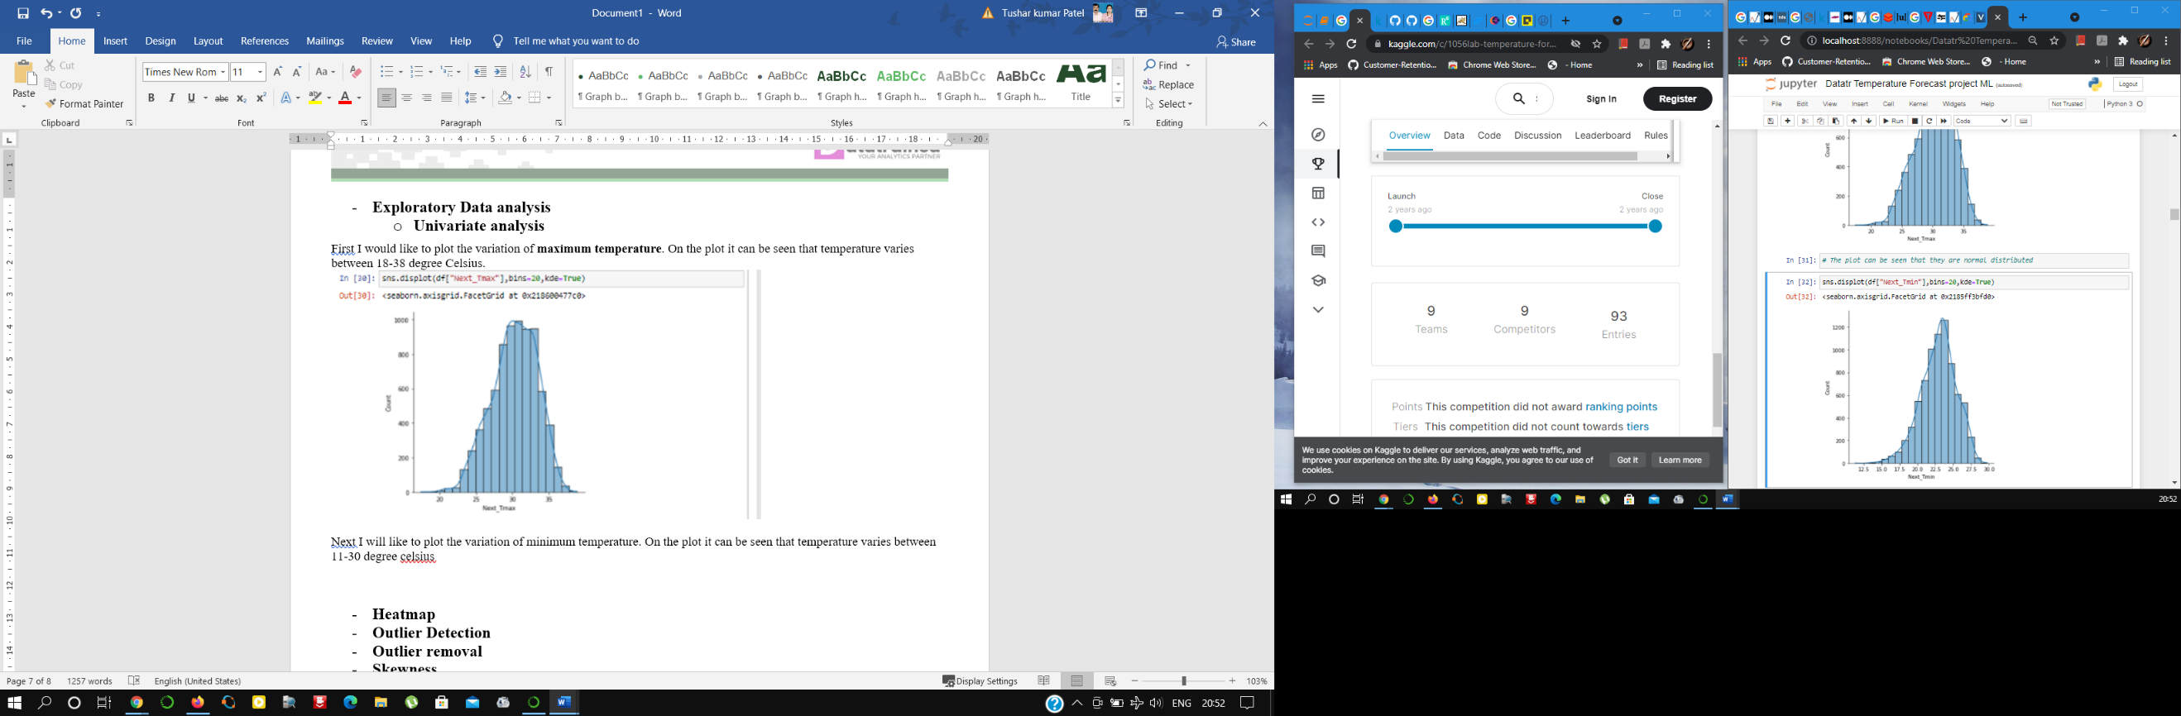

Next is the relation of temperature with humidity.

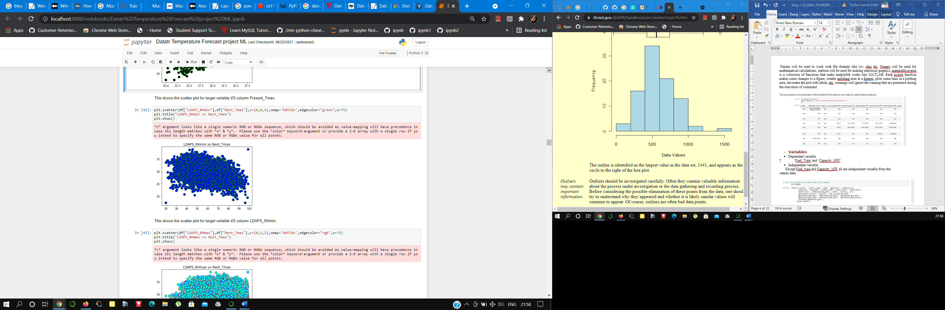

Now checking the relation of temperature with solar radiation.

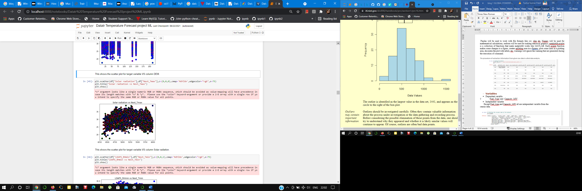

* Heatmap

The next stage of my data analysis is the calculation of the correlation between all the variables.Seaborn heatmaps are appealing to the eyes, and they tend to send clear messages about data almost immediately. This is why this method for correlation matrix visualization is widely used by data analysts and data scientists alike.

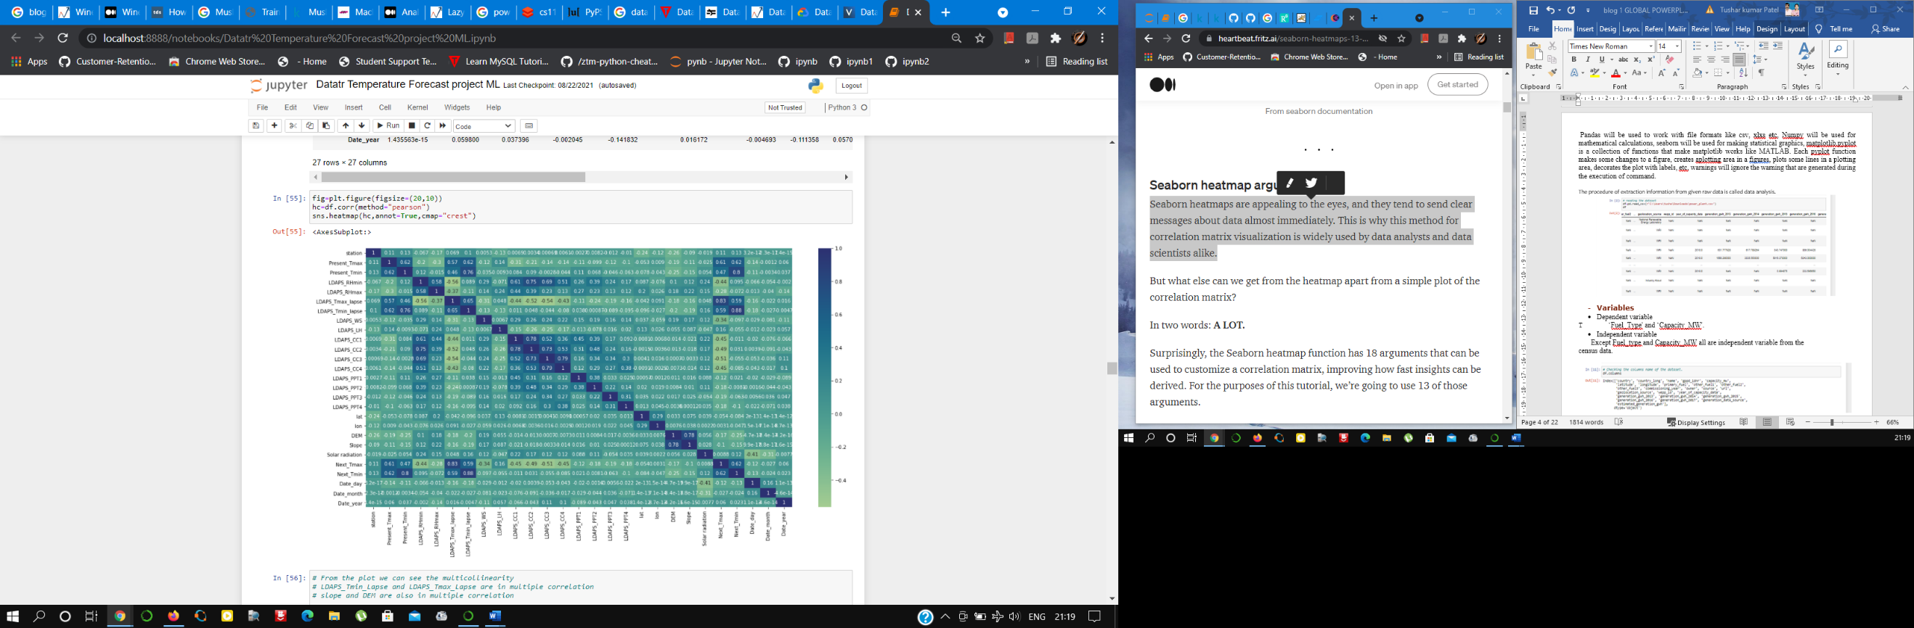

From heatmap we can see the presence of multicollinearity as LDAPS_Tmin_Lapse and LDAPS_Tmax_Lapse are in multiple correlation.

* Outlier Detection

An Outlier is a data-item/object that deviates significantly from the rest of the (so-called normal) objects. They can be caused by measurement or execution errors. The analysis for outlier detection is referred to as outlier mining. There are many ways to detect the outliers, and the removal process is the data frame same as removing a data item from the panda’s data frame.

The simplest way to detect an outlier is by graphing the features or the data points. Visualization is one of the best and easiest ways to have an inference about the overall data and the outliers. Scatter plots and box plots are the most preferred visualization tools to detect outliers.

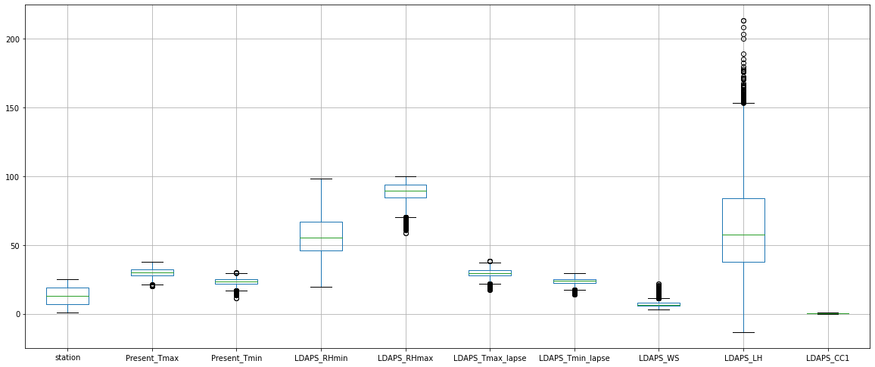

Here we can see the presence of outlier in the dataset, which can be treated using the z-score method.

* Outlier removal

from scipy.stats import zscore

zscr=np.abs(zscore(df))

threshold=3

print(np.where(zscr>3))

the output from the above code is (array([ 25, 25, 26, ..., 7751, 7751, 7751], dtype=int64), array([ 7, 14, 14, ..., 14, 15, 16], dtype=int64))

After using the z-score there will be loss of data which will not be good for us as the data may be very important and very costly so use of outlier treatment can be limited.

After the removal of outliers there is a loss of data which is equal to 11%. Here it is not bad.

* Skewness

According to Wikipedia,” In probability theory and statistics, **skewness** is a measure of the asymmetry of the probability distribution of a real-valued random variable about its mean.”

Skewness basically gives the shape of normal distribution of values.

If skewness value lies above +1 or below -1, data is highly skewed. If it lies between +0.5 to -0.5, it is moderately skewed. If the value is 0, then the data is symmetric.

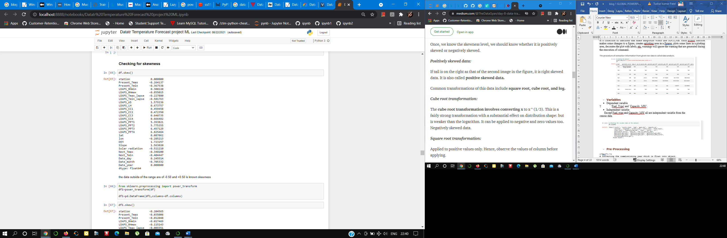

* Model Building

A machine learning model is built by learning and generalizing from training data, then applying that acquired knowledge to new data it has never seen before to make predictions and fulfill its purpose. Lack of data will prevent you from building the model, and access to data isn't enough. Useful data needs to be clean and in a good shape.

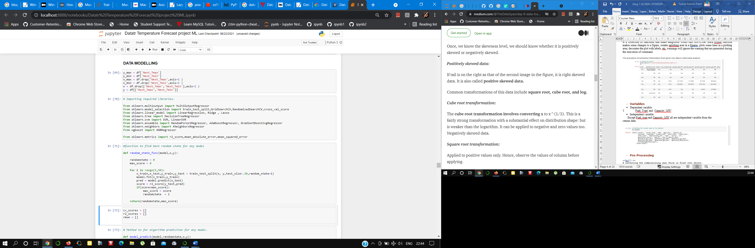

Model building is a very important step for completing the analysis. These four steps, involved for model building which is:

* *Building a baseline:* This is a model that is straightforward but with a good chance of providing decent results, through quick modeling.
* *Designing the model*: This includes selecting a target variable and prediction type.
* *Training the model*: This is done on a subset of the data to evaluate how well it is able to map inputs to outputs and make accurate predictions.
* *Selecting the algorithm and hyperparameters*: Decide which algorithm to use for your model based on your business goals and priorities.
* Train Test and split

The train-test split is a technique for evaluating the performance of a machine learning algorithm.

It can be used for classification or regression problems and can be used for any supervised learning algorithm.

The procedure involves taking a dataset and dividing it into two subsets. The first subset is used to fit the model and is referred to as the training dataset. The second subset is not used to train the model; instead, the input element of the dataset is provided to the model, then predictions are made and compared to the expected values. This second dataset is referred to as the test dataset.

* **Train Dataset**: Used to fit the machine learning model.
* **Test Dataset**: Used to evaluate the fit machine learning model.

The objective is to estimate the performance of the machine learning model on new data: data not used to train the model.

This is how we expect to use the model in practice. Namely, to fit it on available data with known inputs and outputs, then make predictions on new examples in the future where we do not have the expected output or target values.

The train-test procedure is appropriate when there is a sufficiently large dataset available.



* Evaluation metrics

Predictive models have become a trusted advisor to many businesses and for a good reason. These models can “foresee the future”, and there are many different methods available, meaning any industry can find one that fits their particular challenges.

Evaluation metric quantifies the performance of a predictive model.

This typically involves training a model on a dataset, using the model to make predictions on a holdout dataset not used during training, then comparing the predictions to the expected values in the holdout dataset.

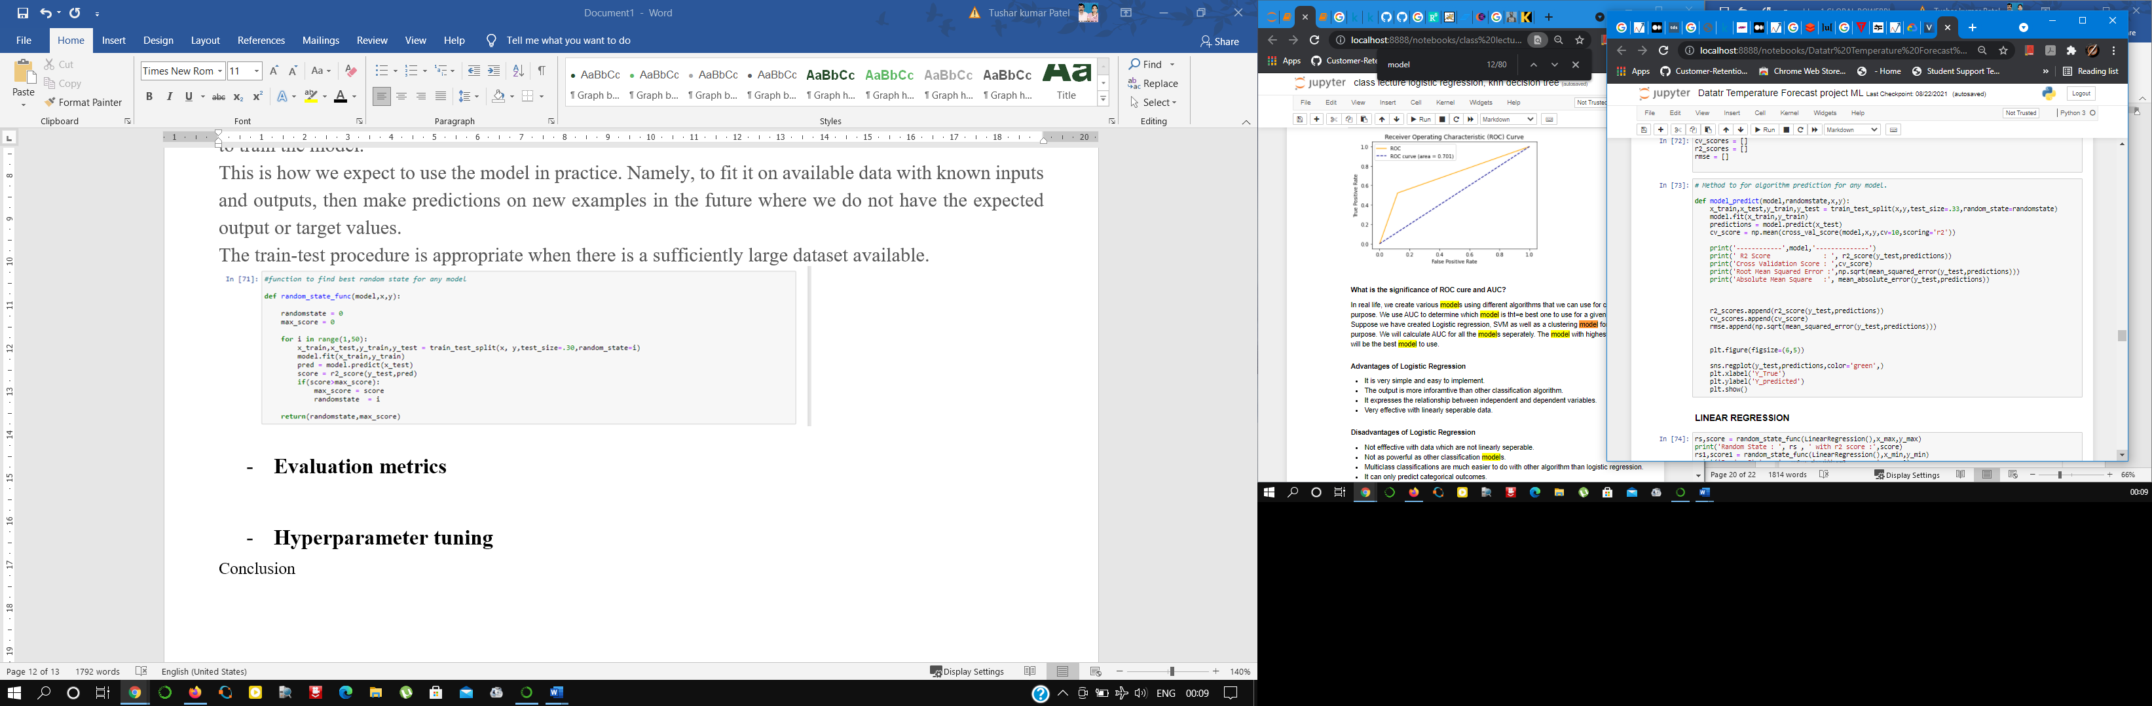

* Hyperparameter tuning

n machine learning, hyperparameter optimization or tuning is **the problem of choosing a set of optimal hyperparameters for a learning** algorithm. A hyperparameter is a parameter whose value is used to control the learning process.

Model parameters are learned from data and hyper-parameters are tuned to get the best fit. Searching for the best hyper-parameter can be tedious, hence search algorithms like grid search and random search are used.

I have selected the RIDGE regression as above while analyzing the data we have seen the multicollinearity condition.

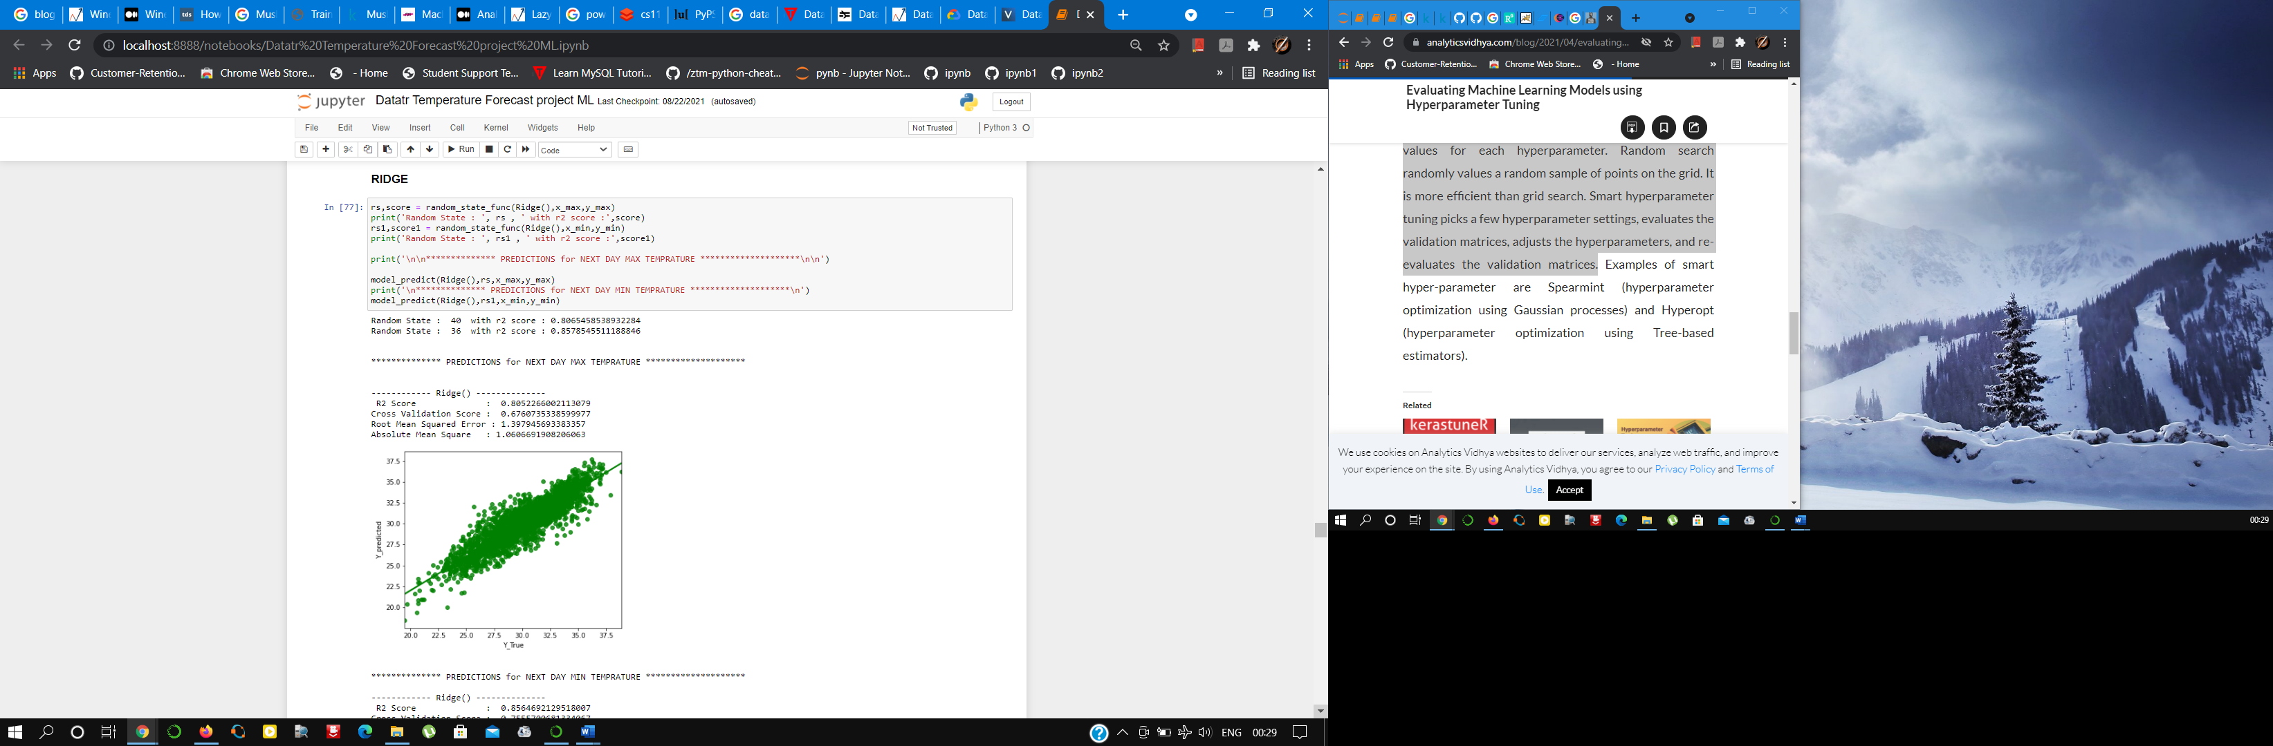

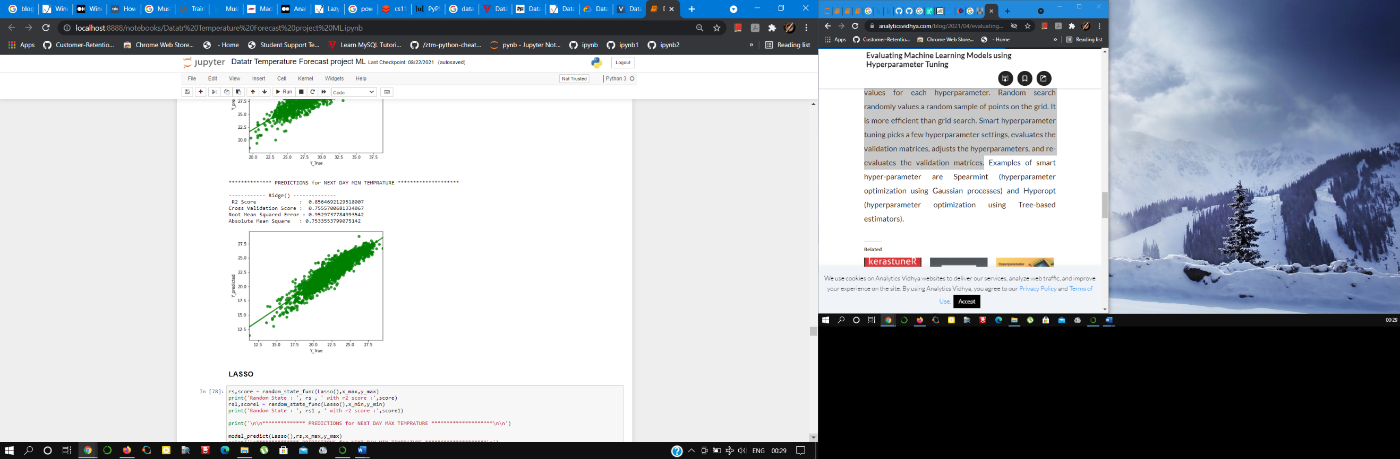

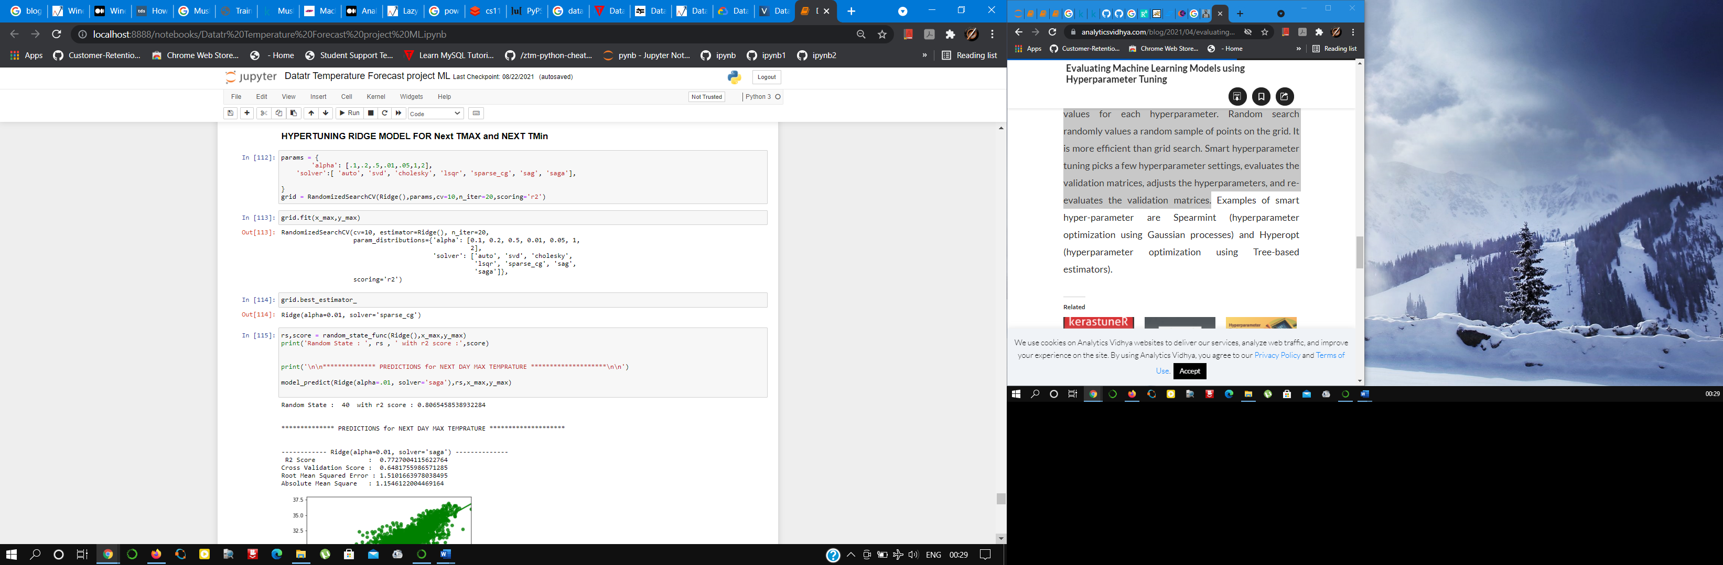

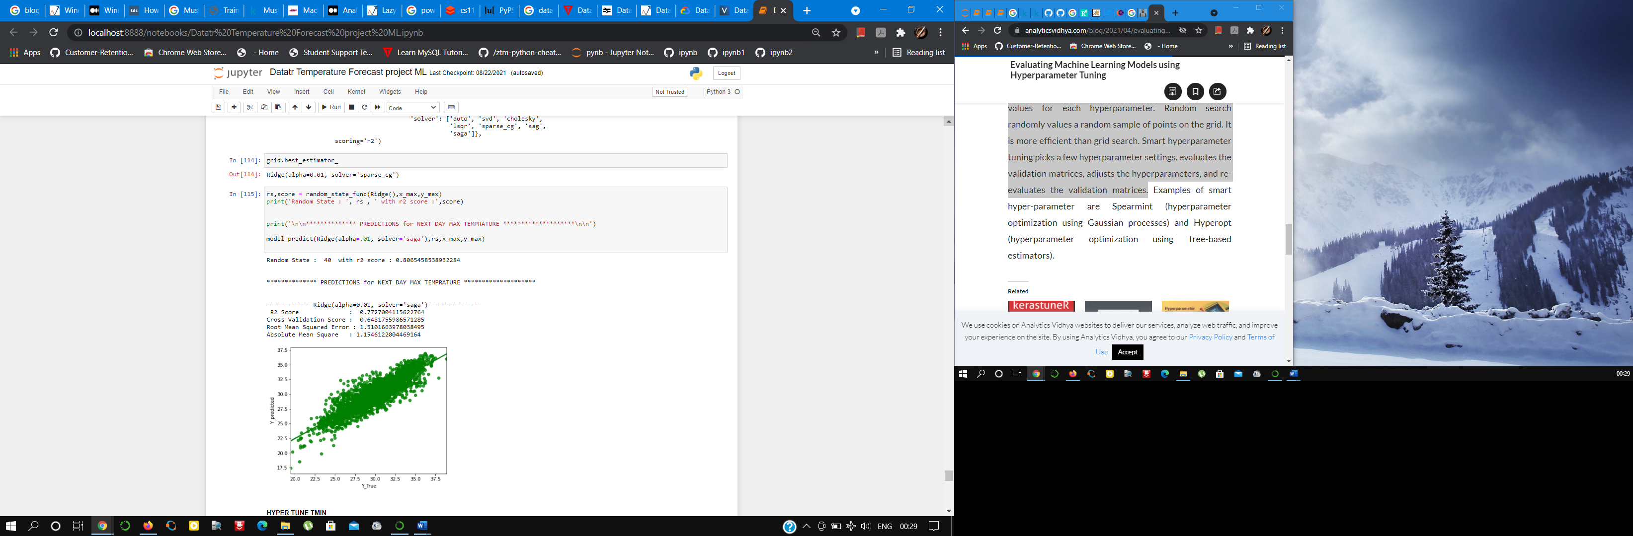

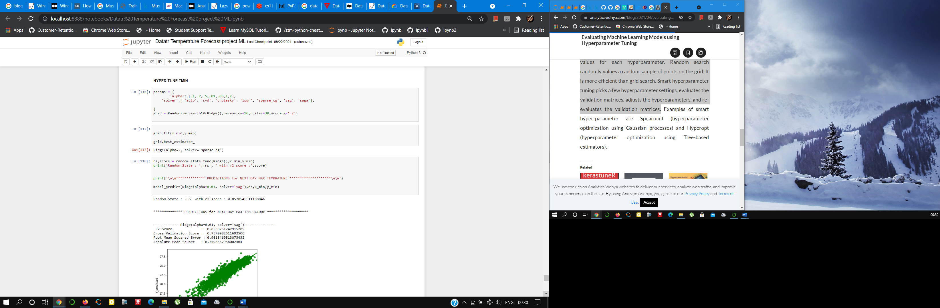

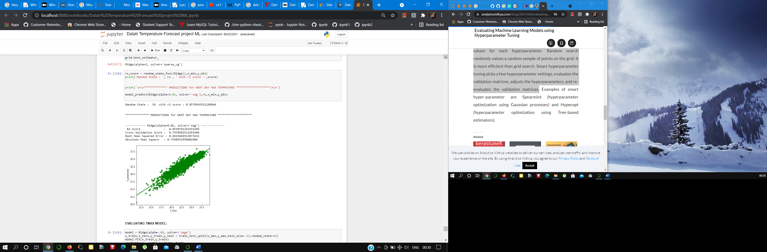

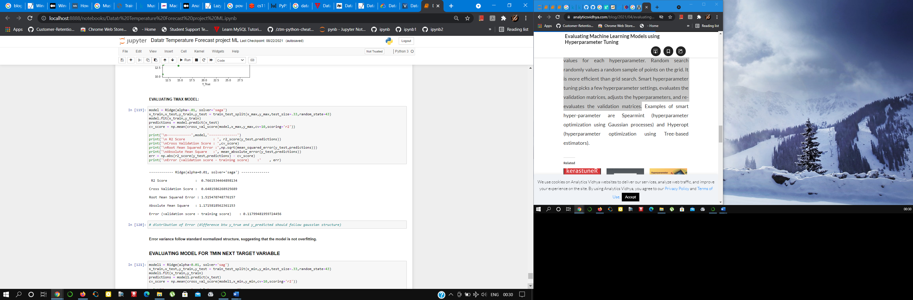

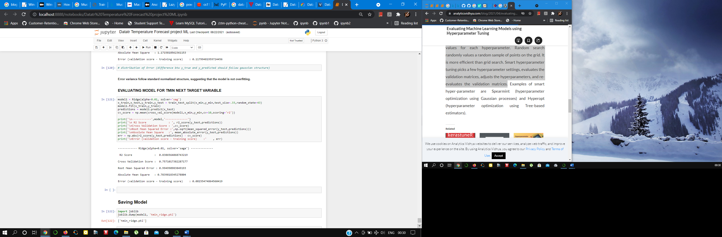

Conclusion

Temperature forecasting is a really difficult task. The machine algorithms can help in prediction for a short tern period to get good results I have used Ridge regression model tuning method as our data was suffering from multicollinearity. When the issue of multicollinearity occurs least squares are unbiased, and variables are large, this results in predicted values to be far away from the actual values.